CHARLES R. PORTER, JR., Ph.D.
Curriculum Vitae
Real Estate Expert, Texas Real Estate Broker
2103 N. Oak Canyon Road
Austin, Texas 78746
crporter@sbcglobal.net (512) 627-3793 www.charlesporter.com

Expert Testimony – Rendered opinions or testified as an expert in lawsuits and arbitration hearings concerning real estate, construction, and water rights nationwide over 800 times.

Education
2016 Doctor of Philosophy, Economics and Business, Cum Laude, Universitat Jaume I,
Castellón de la Plana, Spain
2007 Master of Liberal Arts degree, St. Edward’s University
1974 Bachelor of Business Administration, Finance, University of Texas at Austin

Other Certifications and Education
2014 on Certified as a Broker Price Opinion Resource by the National Association of REALTORS®
2016-on Certified Advanced Instructor Training Institute Texas Real Estate Commission
2005-17 Certified Instructor – Texas Real Estate Commission – Legal I and II/Ethics course
2003-21 Licensed and Certified Instructor - Texas Real Estate Commission, all education courses. (On September 1, 2019, TREC stopped licensing instructors but passed that duty to the TREC approved providers.)
2021-on Certified Instructor Austin Board of REALTORS®, Texas REALTORS®, and the Texas Alliance of Land Brokers.
2003-on Certified Instructor - National Association of REALTORS® Code of Ethics Training
1993 Certified in Family Mediation, Dispute Resolution Center, Austin
1992 Certified in General Mediation, Dispute Resolution Center, Austin
1978 Certified and Licensed as Broker by the Texas Real Estate Commission
1976 Graduate of the Mortgagebanque School of Real Estate, Houston
1975 Certified and Licensed as Agent by the Texas Real Estate Commission

Published Books, Articles, College Textbooks, and Awards

“Condemning Water Rights & Methods of Valuation Under Texas Law”
Co-Authors Edmond R. McCarthy, Jr. and Dr. Charles Porter
State Bar of Texas, 48th Annual Advanced Real Estate Law, July 16-18, 2026,
in San Antonio, Texas

“TREC Contracts Now Include Information on Water Rights”
Texas Realtor Magazine, May/June 2026

“A Guide for Completing the Water Notice: Seller’s Disclosure Notice about Groundwater and Surface Water Rights” by Dr. Charles Porter, St. Edward's University and
Dr. Blake Bennett, Texas A&M AgriLife Extension Service, July 2026
Educator of the Year, Austin Board of REALTORS®, May 2026

Editor of LandWise Journal – Preserving Rural America, May 2026
A peer-reviewed academic journal of expert analysis on all issues
in rural land, law, and public policy.

“What’s a Cap Rate? And How it is Used to Estimate Sales Prices for Commercial Properties”
Texas Realtor Magazine, Jan/Feb 2023

Water Rights and Policies in the United States: A Path Through the Maze
Rowman and Littlefield, New York/London, Summer 2023
(A College Textbook)

Awards in Education, Industry, Community Service, and Publications

Elected President of the Board of Directors of Light of Christ Montessori School
St. John Neumann Catholic Church, November, 2024

Elected Grand Knight of the St. John Neumann Knights of Columbus Chapter 10836
2024-2025

Exemplified as 4th Degree Knight of Columbus, 2024

Invited panel member of “Finding a Balance: Groundwater Availability in Texas” at the Texas Water Development Board’s Water for Texas, 2023 Conference, January 2023

Appointed Chairman of the Advisory Council of the Briscoe Center for American History at the University of Texas 2021-2024

Appointed to the Texas Real Estate Commission as Alternate to the
Broker/Lawyer Committee 2021 through 2023
Elected Chair of the Texas Real Estate Commission
Education Standards Advisory Committee, 2022

Working member of the Legal I and Legal II Writing Committee; Co-Author of the Legal I and Legal II Mandatory Continuing Education Manuals 2022-2023 version,
Texas Real Estate Commission, 2021-2022

Working member of the Broker Responsibility Writing Committee; Co-Author of the Broker Responsibility 2022-2023 version, Texas Real Estate Commission, 2022

Appointed by the Texas Real Estate Commission to serve on the Farm and Ranch Working Group of the Broker-Lawyer Committee 2021-2022

Appointed by the Texas Real Estate Commission to the
Education Standards Advisory Committee 2019-2023

Elected to the National Association of REALTORS® Board of Directors 2017 – 2024

Elected to the Texas REALTORS® Board of Directors 2022-2024

2009 Best Ethics Education Program in the State of Texas for
“Water Rights for Texas Real Estate Agents” a TREC MCE course
Charles Porter, author and instructor

2005 Best Education Program in the State of Texas for
“Mediate, Arbitrate, Litigate” a TREC MCE Course
Charles Porter, author and instructor
2015 Outstanding Capstone Instructor
St. Edward’s University

2013 Hudspeth Award for Innovative Teaching
St. Edward’s University

2011 Outstanding Adjunct Professor
School of Behavioral and Social Sciences
University Programs
St. Edward’s University

2008 Presidential Award, St. Edward’s University

2008 Outstanding Master of Liberal Arts Graduate, St. Edward’s University

2008 Master of Liberal Arts 4.0 Club, St. Edward’s University

2009 Realtor of the Year, Austin Board of REALTORS®
2008 Chairman’s Award for Distinguished Service, Austin Board of REALTORS®

2007 Peacemaker Award, Dispute Resolution Center

2006 Chairman’s Award for Distinguished Service, Austin Board of REALTORS®

Academic Writing Honors Awarded to Dr. Charles Porter

San Antonio Conservation Society
Best History Book Award, Years 2009 and 2010
Spanish Water/Anglo Water, Texas A & M University Press, 2009

Texas Old Missions and Fort Restoration Association
For Outstanding Published Book
Contributing to a Better Understanding of Spanish Colonial Texas
For Spanish Water/Anglo Water, Texas A & M University Press, 2009

The Chamberlain Award
“The History of W.A. East v. Houston and Texas Central Railway Company, 1904: Establishment of the Rule of Capture in Texas Water Law or ‘He Who Has the Biggest Pump Gets the Water’”
in the East Texas Historical Association’s Volume L, Fall 2012, 50th Anniversary East Texas Historical Journal

The Robert S. Weddle Award
“Querétaro in Focus: the Franciscan Missionary Colleges and the Texas Missions”
in Texas Catholic Historical Society’s Volume 19, 2008
Catholic Southwest: A Journal of History and Culture
Most Recent Texas Real Estate Commission Professional
Continuing Education Credit Classes for Agents:

Advanced Farm and Ranch Contracts
Advanced Water Rights for Texas Agents
Advanced Farm and Ranch for Texas Agents
Advanced Farm and Ranch Practice Update

Authored and taught by Dr. Charles Porter and Jason Hill, Attorney-at-Law, J T Hill & Co.
November 2017, 2018, 2019, 2020, 2021,2022,2023,2024, 2025

Since 2003, Porter has authored and taught TREC CE classes an average of 14 times annually across Texas. The courses listed above have been updated and renewed every two years if not more often.

Other TREC CE Classes Authored and Taught by Dr. Porter
21st Century Residential Property Management, 2024
BPOs in the Rio Grande Valley, 2024
Farm and Ranch Update, 8-Hour, 2024-2025
Minerals for Texas Agents, 2022 to date
Farm and Ranch. 4-Hour, 2003 to date
Farm and Ranch, 7-Hour, 2003
Water Rights for Texas Agents, 2005 to date
Water Rights for Commercial Agents, 2022 to date
Mediate, Arbitrate, Litigate, 2003 to date
Commercial Finance for Agents, 2017
Several One-Hour Water Rights Classes

Dr. Charles Porter 2026 Active Authored and Teaching
TREC Continuing Education Classes

For Texas REALTORS®

06131-RECE 21st Century Residential Property 3 hours
05909-RECE Farm and Ranch for Agents 4 hours
06052-RECE Introduction to Texas Water Rights 2 hours
06400-RECE Waters of the United States (WOTUS) 1 hour

For the Texas Alliance of Land Brokers

32977-RECE Advanced Farm & Ranch Contracts 3 hours
32971-RECE Advanced Texas Water Rights for Agents: The Texas Water Code 8 hours
32979-RECE Duties of Agents in the Commitment for Title Insurance 1 hour
32972-RECE Farm and Ranch Practice and Legislative Outlook for 2025 8 hours
Pending Farm and Ranch Practice and Legislative Outlook for 2027, 8 hours
32975-RECE Farm and Ranch Update For 2025 8 hours
32976-RECE Introduction to Farm and Ranch Contracts for New Agents 3 hours
32970-RECE Introduction to Farm and Ranch for Agents 4 hours
32969-RECE Introduction to Water Rights to Agents 4 hours
32974-RECE Mineral Rights for Agents 3 hours
32978-RECE Special Considerations in Farm and Ranch Valuation & Management 8 hours
32980-RECE Water Regulations for Agents in 2026 2 hours

For the Austin Board of REALTORS®

24363-RECE Code of Ethics 3 hours ( I teach this class without compensation as a public service to the members of the Austin Board
24368-RECE Farm and Ranch 4 hours
24350-RECE Water Rights for Texas Agents: The Basics 4 hours

Class Approved for State Bar of Texas Continuing Education

Evaluating Commercial Properties for Eminent Domain Cases
Authored and taught for the Texas Attorney General’s Office, Right-of-Way Division, 2009

Real Estate Development, Management, and Brokerage Activity

1977-2019 Real Estate Development, Management, and Consulting
The following properties were planned, developed, constructed, financed, sold, and managed by Charles Porter through various limited partnerships:

Property Type Size Location
Augusta Landing * Condominiums 21 Houston
Oaks of Augusta Condominiums 30 Houston
Timberchase Condominiums 32 Houston
Cottonwood Condominiums 30 Houston
Briar Station West Condominiums 35 Houston
1502 Augusta Office Building 65,000 sf Houston
Quail Harbor Condominiums 88 Houston
3555 Briarpark Office Building 74,000 sf Houston
Rutgers Place Townhouses 9 West University
Rutgers Place II Townhouses 9 West University
Harborgreen Condominiums 96 Houston
1811 Bering Drive Office Building 80,000 sf Houston
Town Oaks Place Townhouses 20 Bellaire
Belmont Oaks Townhouses 12 West University
Gramercy Park Condominiums 53 Houston
Drexel Place Apartment/THs/Rental 24 Houston
Weslayan Oaks Apartments/Rental 84 Houston
Weslayan Oaks II Land 1.25 ac Houston
Twin Cities Plaza Retail Center 23,000 sf Rosenberg
Twin Cities Plaza II Land 6.7 ac Rosenberg
Robinson Creek Medical/Office 80,000 sf Huntsville
Fleming Companies Grocery Store/Build to Suit 42,000 sf LaMarque

(14 multi-family projects, 3 office buildings, 1 retail center, 1 retail/office center, and 1 grocery store build to suit, 2 planned multi-family second phases) * As project manager only – no ownership.

1978-1991 Organized/ President of 14 Condominium or Homeowner’s Associations including serving as President of the Lynn Park Homeowner’s Association from 1985-1989

1987 to Date Active Broker in Commercial & Residential Real Estate in Texas
Owner’s Representative in Construction Projects; Expert Witness Consultation

Recent Brokerage Highlights:

Listing Agent for farm property on CR 406, Taylor, Texas – one mile from the Samsung Plant

Listing Agent for sale of 1208 E. 7th Office building; successfully sold and closed in 2010.

Completed acquisition of the 33 acre Dellana Tract in Rollingwood and Austin at the intersection of MoPac and Bee Caves Road for American Retirement Corporation and representation of ARC for the subsequent platting, re-zoning and establishment of a PUD, followed by service as the listing broker sale of 16 acres of the 33 acres fronting on Bee Caves Road; total value of project $12,000,000 +.

Acquired 10,000 s.f. office space for CFX Engineering, Inc. in The Overlook, Austin.
Acquired an additional 22,000 s.f. office space for CFX, L.P. in Austin.

Completed roof system replacement as Owner’s Representative for Kappa Delta.

Listing agent for American Retirement Corporation’s 2003 10-acre Ft. Worth site, sold to Plaza Mercedes including land development feasibility.

Listing agent for American Retirement Corporation’s 2003 17-acre Dellana Austin site, sold to Cencor and Live Oak Development entities. The work included hiring civil engineers (CFX Engineering) to solve site plan problems with the City of Austin.

Listing agent for Scott Stine/NTS 3.27-acre tract on RR 620 in Bee Cave, Texas, sold to Discount Tire Company. I also assisted Scott in acquiring sanitary sewage capacity for the tract from the Lower Colorado River Authority. We negotiated with the LCRA to exchange a temporary lease of the lower portion of the tract for a sanitary sewage manhole on the property along with the capacity we needed.

Listing agent for LIC’s Onion Creek commercial frontage (with Joe O’Connor), sold to Brad Smith and Scott Farley. Lumbermen’s required me to find the civil engineering firm (Carl Conley) and Enviroplan (Gary Payne) as architect to create the site development plan for approval by the City of Austin before marketing the property.

Leased 10,949 sf to Sachem at The Overlook in Austin for CFX, 2002.

Listing agent for 123 Acres at IH35 and SH 287 in Waxahachie, Texas. This also involved acquisition of sanitary sewage for the tract. In exchange for an easement across the tract, we negotiated sanitary sewage capacity and manholes on the tract that previously had none.

Listing agent for 9+ acres at the intersection of FM 1626 and FM 967 in Buda, Texas. I also worked with Carl Conley as the civil engineer on the property to determine utility characteristics of the tract prior and during marketing.

Since 2001, represented 12 clients either as buyer’s agent or seller’s agent in single family residential transactions in Travis and Blanco Counties.

Texas Real Estate Commission Certified Continuing Courses as Instructor

Teaches or has taught in the past the mandatory promulgated “Legal/Ethics Update,” “Legal/Legal”, “NAR Code of Ethics.” Teaches the courses Porter authored titled “Advanced Water Rights for Texas Agents” co-authored with Jason Hill, Attorney-at-Law, “Commercial Finance for Texas Agents”, “Water Rights for Texas Agents,” “Farm and Ranch for Texas Agents,” “Mediate, Arbitrate, Litigate.” Total real estate for industry teaching equals approximately 100 class hours annually.

Service to the International Community
2017 – Speaker and panel designer of “Case Studies in the Challenges of Water Sharing Between “Upstreamers' and “Downstreamers” for the World Water Congress, Cancún, México, May, International Water Resources Association. “IWRA is an international network of multidisciplinary experts on water resources. We are a non-profit, non-governmental, educational organization established in 1971. IWRA provides a global, knowledge-based forum for bridging disciplines and geographies by connecting professionals, students, individuals, corporations and institutions who are concerned with the sustainable use of the world’s water resources.”
2012 – 2015 Appointed by the United States National Parks Service as one of twelve
International experts to support and review the National Parks Service Nomination of the San Antonio River Missions to gain World Heritage Designation. Served as guest Editor/Reviewer. “Application by the National Parks Service San Antonio River Missions for World Heritage Nomination by UNESCO: for ICOMOS United States and International” as a member of the International Expert’s Committee of the National Parks Service. Continues to serve on the committee to discuss the nomination with various inspectors from UNESCO and ICOMOS.
Service to the State and National High School History Community

2012-17 Judge of the High School History Day Papers for the Texas State Historical
Association, the winners of which are entered into the National History Day Paper contest.

Service to the Texas Legislature

2018 Testified at the invitation of the House Natural Resources Committee concerning the current state of water markets in Texas. The hearing was held at Baylor University.

2014-16 Private sponsor and author of HB 1221, with live testimony at the House Natural Resources and Senate Business and Commerce Committee Hearings (the only witness). HB 1221 was my idea, and over a two-year period, I gathered a committee of attorneys and water experts to draft the bill, then presented the bill to the Texas Association of REALTORS®, the Texas Alliance of Groundwater Districts, the Texas Water Conservation Association, and countless other trade associations and groups, including the State Bar of Texas. I received unanimous support from political groups and trade associations representing over 250,000 members. The bill was signed into law by Governor Abbott on June 17, 2015 effective January 1, 2016. It amended the Texas Property Code Section 5.008 to include a question requiring the seller of a residential property in Texas to disclose their knowledge about the property being in the jurisdiction of a groundwater conservation district, the local regulatory agency over groundwater in Texas. Over the first ten years of this revision, over 39,000,000 participants in residential real estate transactions will be forced to answer or read this question.

2016 The Chair of the Texas House of Representatives Interim Natural Resources Committee invited me to testify on February 9 in a hearing in Burleson, Texas, about the consequences of the Waters of the United States EPA ruling and to update the committee on challenges in groundwater management in our current groundwater conservation district system.

Porter’s Published Books, Articles, and Interviews

Books:

2023 Water Rights and Policies in the United States: A Path Through the Maze. Rowman and Littlefield, New York/London. 2023.

2018 Public Water Policies: The Ultimate Weapons of Social Control. Rowman & Littlefield, Bernan Impress, 2018.

2014 Sharing the Common Pool: Water Rights in the Everyday Lives of Texans,
Texas A & M University Press, 2014.

2009 Spanish Water, Anglo Water, Texas A & M University Press, 2009.

Peer-reviewed Journal Articles, Academic Conference Papers, and other Articles:

2020 “Diving into Water Rights: A Primer for Land Agents,” Terra Firma Magazine, Summer, for REALTORS® Land Institute.

2019 “Building Competency in Real Estate” Texas Realtor Magazine, November.

2018 “Of Urgent Concern: What Prompted House Bill 162, the Groundwater Conservation Act of 1949” published in January 2018 in the Panhandle Plains Historical Review, Volume LXXXVIII, 2017, West Texas A & M University.

2017 “Navigating Seller’s Disclosure after Harvey,” Texas Realtor Magazine, November. Porter co-authored with Gary L. Pate, Attorney-at-Law.

2017 “Methods and Challenges in the Credible Valuation of Water Rights in Texas, Updated” for the Texas Water Law Superconference, Austin, June, 2017.

2017 Book Review: Heads Above Water: The Inside Story of the Edwards Aquifer Recovery Implementation Program.” Southwestern Historical Quarterly Vol. CXX, No. 5, 407-408. Texas State Historical Association.

2016 “Methods and Challenges in the Credible Valuation of Water Rights in Texas” for the Texas Water Law Institute, The University of Texas School of Law. November. Porter co-authored with Ed McCarthy, Attorney-at-Law.

2016 “Public Water Policies: The Ultimate Weapons of Social Control”. Formally accepted on May 9, 2016, published in AABRI’s (Academic and Business Research Institute) “Research in Business and Economics Journal,” June, 2016, manuscript 162390. The journal is listed in Cabell’s.

2015 Texas Water Law Conference Papers in Austin on October 6, my peer-reviewed and published paper was titled: “Of Urgent Concern” - What Prompted House Bill 162, the Groundwater Conservation Act of 1949.

2015 Book Review: “Southern Waters: The Limits of Abundance.” Environmental History, Volume 20, July 2015, 561-562. Oxford Journal, Oxford University Press.

2015 State Bar of Texas 16th Annual Changing Face of Texas Water Rights Conference Papers, my peer-reviewed and published paper was titled: “What You Think You Know About the History of Texas Water… But Don’t.”

2015 Article published in Texas Realtor Magazine, “What you need to know about mineral rights.” January/February issue.

2014 “Groundwater Conservation Districts in Texas: Still “Undisclosed” After 65 Years – Except at the Austin Board of REALTORS®!” published in the Austin Realtor Magazine. November/December.

2014 “A Perspective on Realistic and Sustainable Water Policy: Workable Solutions for a Bright Future” was published and presented at the 6th Annual Lone Star Water Forum.

2014 “Undisclosed: Groundwater Conservation Districts in Texas Real Estate Transactions.” Published and presented at the 24th Annual Superconference Texas Water Law. CLE Water Law Institute.

2014 “5 free resources for your farm and ranch clients” published in Texas Realtor Magazine. August.

2015 “Moot Mediations in Global Transboundary Water Disputes: Teaching Peaceful Problem- Solving in International Water Relations” published and presented for the World Council for Curriculum and Instruction 16th World Conference on Education Integrating Education for a Lasting Culture of Peace and Care of Planet Earth.

2014 Contributor to Dr. Patrick Cox’s Ranching in the Wild Horse Desert: A History of the
Jones Family Ranches. (Privately Published).

2014 “Water Rights 101: Unrealized and Undisclosed” published and presented at the South
Texas College of Law 29th Annual Real Estate Law Conference June. Houston.

2014 “General Information on Groundwater Districts for ABOR's Risk Reduction Committee” published by the Austin Board of REALTORS® and also the Texas Association of REALTORS® Public Policy Infrastructure and Utilities Subcommittee. June. Austin.

2013 NPR Interview – “The History of the Texas Water Plan” aired May 28, 2013 on Impact Texas.

2013 “Groundwater Conservation District Finance in Texas: Results of a Preliminary Study” Texas Water Journal, Volume 4, No. 1, a peer-reviewed journal of Texas A&M University.

2013 “Reinventing Realities: Creating Identity and Community through Oral History,” published in the conference proceedings of the Southwest Oral History Association Annual Conference, Las Vegas, Spring, 2013.

2013 A magazine article written by Charles Porter "Living on the Land" The Bullock Texas State History Museum Star, Winter 2013.

2012 “The History of W.A. East v. Houston and Texas Central Railway Company, 1904: Establishment of the Rule of Capture in Texas Water Law or ‘He Who Has the Biggest Pump Gets the Water’” in the 50th Anniversary Issue of the East Texas Historical Journal, Fall, 2012. This article won the Chamberlain Award for the best journal article of 2012.

2012 “Water Rights and Everyday Real Estate Transactions,” for the 22nd Annual Water Law Conference, the Water Law Institute. For continuing education for attorneys in Texas.

2012 "300 Years of Water Management in Texas: From Viceroys to GCDs," for the Texas Groundwater Summit sponsored by the Texas Alliance of Groundwater Districts.

2012 “The 18th Century Blas Hererra Home: A Scientific Analysis of Materials and A History of the Land and Buildings,” Editor Charles Porter, a book published by Drawing Sounds Publishing Company owned by Charles Porter.

2012 “Bells and Belfries: Control or Comfort for the San Antonio River Missions?” presented and published in the conference papers at the Annual Conference of the World History Association in Albuquerque, New Mexico.

2012 Interview in Texas Observer Magazine, Q & A’s – http://www.texasobserver.org/forrestforthetrees/questions-for-charles-porter
2012 Interview in YNN News, Austin, Texas on the status of groundwater regulation in Texas in light of the Day McDaniel v. Edwards Aquifer Authority ruling by the Texas Supreme Court.

2012 “Water: The Aorta of Life and Community Continuity in the San Antonio River Missions” National Parks Service documents of the Expert Committee for the World Heritage Designation of the San Antonio River Missions for UNESCO.

2012 Interview in the New York Times, February 26, Sunday Texas Tribune Section, “If Conservation Fails, Industry May Try Groundwater.” Written by Kate Galbraith.

2011 A guest editorial written by Charles Porter “Texas Out of Water?” Houston Chronicle Guest Editorial, Sunday, October 23.

2011 Class Manual in peer review by the Texas Real Estate Commission
TREC Course, # to be announced, 7-hour “Farm & Ranch for Agents.”

2010 “Duties in Disclosure of Defects in Single Family Residences in Texas” nationally
published by the Technical Advisory Service for Attorneys, Blue Bell, Pennsylvania, at TASAnet.com Knowledge Center under TASA ID#712958568, written by invitation of TASA http://www.tasanet.com/knowledgeCenterDetails.aspx?docTypeID=1&docCatID=35&docID=160
Also published in the Austin Realtor magazine, November/December 2010

2010 “Early Water Policy in Texas” published in Confluence, 2nd Quarter, magazine of the Texas Water Conservation Association http://www.twca.org/downloads/newsletters/2010q2-confluence.pdf

2010 The Hydraulic West, a chapter in The World of the American West, edited by Gordon Bakken to be published in December 2010 by Routledge (a division of Taylor-
Francis, New York)

2010 “Water Shares” Author’s Note, page 33, June 25, 2010, Texas Observer magazine

2008 Author (& Instructor) - “Brokers and Eminent Domain” for State Bar of Texas Continuing Legal Education Credit, presented exclusively to the State of Texas Assistant Attorney Generals in the Right of Way Division

2008 “Querétaro in Focus: A History of the First Missionary Colleges in the New World” published in Catholic Southwest Journal and winner of the Robert Weddle Award for the best journal article of 2008.

2008 “Gotcha’s” - HB 3070 Residential Energy Efficiency Advisory Committee,
Report for the State Energy Efficiency Task Force, distributed to the Task Force and Members of the Texas House of Representatives; peer-reviewed by Texas A & M University’s Real Estate Center

2007 “The Importance of the Seller’s Disclosure Notice” Austin Realtor magazine,
September/October issue

2003 “Ethical Conduct by Real Estate Agents is Serious in Texas”
Austin Realtor magazine, March/April issue

2002 “Mediation Basics”, chapter in the Austin Ethics/Grievance Training Manual

1999 “Preparing for Small Claims Court for Non-Attorneys” published by Judgment
Services Company

1999 “Ground Leases for Commercial Properties, “a private commissioned study for
American Retirement Corporation, NYSE, published internally.

1996 “The Effect of Controlled Access Gates on Selected Apartment Properties in
Austin, Texas,” presented in testimony to and reviewed by the House Urban Affairs
Committee of the Texas Legislature, 1998, and distributed to members of the Texas
House of Representatives

1992 “How to Successfully Collect Your Judgment in Texas” published by
Judgment Services Company

Porter Editing and Reviewing for Fees

2017 Reviewer/editor of “Barton Creek” for Texas A & M University Press.

2014 Reviewer/editor of John Williams “The History of the Lower Colorado River Authority”
For a fee, Texas A & M University Press published a book in late 2014.

2013 Reviewer/editor for “A Defiant River” for the East Texas Historical Association, a
Journal article for the ETHA Historical Journal.

2013 Reviewer/editor of John Corona's "In the Common Interest" for fee, Texas A & M
University Press.

2011 Reviewer/editor of Dr. Charles Guilliand’s “Buying Land in Texas” for fee
Texas A & M University Press, book publication late 2011.

2011 Review of Dr. Tom Hatfield’s “The History of the 1950’s Drought” pro bono
With recommendation to Texas A & M University Press to publish.

Porter Other Publications Peer-Reviewed or Court-Reviewed

2017-2021 TREC Continuing Education Course and manual, “Advanced Water Rights for Texas Agents,” with co-author Jason T. Hill, Attorney at Law and Principal at Lloyd Gosselink Law, Attorneys at Law, course #33150.

2012-2022 Updated Class Manual “Water Rights for Texas Agents” TREC Continuing Education Course #004-00-064-24518 and “Farm and Ranch for Texas Agents” TREC Continuing Education Course #07-00-084-24796.

2003 to date Class Manuals authored by Porter, which are peer-reviewed by the Texas Real Estate Commission (TREC) and approved for continuing education credit for all real estate licensees in the state of Texas:

TREC Course # 04-00-081-8335, 4 hour “Mediate, Arbitrate, Litigate”
TREC Course # 04-00-121-8758, 4 hour “Farm & Ranch for Agents”
TREC Course # 04-00-030-6748, 4 hour “Water Rights for Agents”

1987 to date 200+ Opinion letters in various state, local, and federal court cases
nationwide, involving real estate and construction issues in over 500 cases in
Porter was named an expert witness

Pending or Upcoming Publication of Books and Articles Authored by Charles Porter

2019 Under Contract with Rowman & Littlefield – a new college textbook
Water Rights in the 50 States: A State by State Analysis

2018 In Review “The Beginnings of Spanish Settlement in the El Paso District Revisited.”

2018 Upcoming George W. Brackenridge: Maker of Modern Texas, in first edit

2018 Upcoming “Civil War San Antonio: A Realistic Supply Source for Sibley’s New
Mexico Campaign of 1861-1862”, in edit

Appointments at St. Edward’s University

2013/2014/2015/2016/2017/2018
Appointed Editor-in-Chief of “Pangaea Journal – Pangaea Global Connections: Student Views on Globalization,” Volumes 5 and 6 – the first fully online journal at St. Edward’s.
2017/2018
Appointed Visiting Assistant Professor in College of Humanities - University Studies.

2013/2014/2015/2016/2017
Appointed Visiting Assistant Professor in College of Education - University Studies.
2011/2012/2013
Appointed Assistant Professor of History in Behavioral and Social Sciences.

2010/2011
Appointed Adjunct Professor in Behavioral and Social Sciences, University Programs, and New College to teach 8 courses from Capstone to U.S.History I and II, including CULF 3331, Global Water Challenges which Porter authored.

2009/2010
Appointed Adjunct Professor in the Undergraduate School, Behavioral and Social Sciences, History, “Southwest Borderlands – A History of the Texas Missions HIST 2399,” “The Spiritual Conquest of Mexico HIST 2399,” and “United States History I HIST 1301”

Appointed Adjunct Professor in the Undergraduate School, University Programs, Cultural Foundations Core Courses, “American Experience CULF 1320, American Dilemmas CULF 2321, Cultural Foundations – Global Water Issues CULF 3331, and Capstone, CAPS 4360”

2008/2010
Appointed Adjunct Professor in the New College at St. Edward’s University – teaching Freshman American History A-HIST 1301 and A-HIST 1302 and as author of “Spanish Roots in Texas History A-HIST 4346 (2008)”

As Adjunct Professor, 126 classes, author of 18:
Fall, 2014-2019 “Global Water Issues” CULF 3331
Spg, 2014-2017 “Real Estate Finance” FINC 4343
Fall, 2018 “Environmental Politics and Policy” ENSP 4330
2017-2019 “Special Project – MLA” “Magazine Article Writing”
LACC 6399/LADS 6371 – Graduate School
Summer, 2017 “Magazine Article Writing” LAEC 6318 – Graduate School
Spg, 2017 “Water Policy and Governance” ENSP 2349/POLS 2349
Fall, 2016 “Water Rights in Texas” ENSP
2015-2016 “Honors Dilemmas”, “Honors Global Water Issues” HONS 2321, 3331, 2360
Fall, 2013 “Austin Experience” CULF 1320
Fall, 2012 “Austin Dilemmas” CULF 2321
Fall, 2012 “Enduring Women” with Dr. Mary Brantl and Bill Kennedy
Fall, 2010 “Issues in Globalization, Water” CULF 3331
Spring, 2010 “The Spiritual Conquest of Mexico” HIST 2399
Fall, 2009 “Southwest Borderlands: History of the Texas Missions”
HIST 2399
Summer, 2008 “Spanish Roots in Texas History” A-HIST 434
Appointed Service to St. Edward’s Community

2015-17 Member of the Academic Integrity Assessment Committee of St. Edward’s University.

2013-14 Hudspeth Award Committee; review and determine 2013-2014 and 2014-2015
winner.

2013-18 Appointed Editor in Chief of “Pangaea Journal – Pangaea Global Connections: Student
Views on Globalization” Volumes 5 and 6 – the first fully online journal at St.
Edward’s.

2012-18 Appointed to two three year terms as a Board of Directors Member of the St. Edward’s University Alumni Association.

2012 Appointed to be the Oral History Expert for the Enduring Women presentation
at the Bob Bullock State of Texas History Museum, Fall 2012, Spring 2013.

2011 MLA Advisor Search Committee – Interviews of Candidates

2011 MLA Committee – Community Engagement: Life Stories, Working Draft

2010 MLA Committee – Concentration in Writing Children’s Literature Investigation

2009-15 Appointed to Friends of MLA, Advisory Council of the Master’s of Liberal Arts

2009 Appointed to the Advisory Council of the New College at St. Edward’s University

2008 Founder of the St. Edward’s University Master of Liberal Arts Alumni
Association and host of the initial party at the Austin Club

2007 Appointed to the Graduate Council of St. Edward’s University Graduate School, Master of Liberal Arts Program Student Representative

Seminars Attended at St. Edward’s University

2010-17 Presenter/volunteer at the Teaching Excellence Showcase on a variety of topics
2017 Night with Chris Gabel and Marianne Dwight, International Water Rights Attorneys,
“The Rio Grande” (sponsor and organizer)
2016 Night with Catherine Heidrick and St. James Episcopal Church members who
volunteered in McAllen for the relief of mothers and children refugees from Central
America, (sponsor and organizer)
2014 Night with the former Mayor of El Paso, Bill Tilney, (sponsor and organizer)
2013-14 Holy Cross Institute
2012 Ethics Seminar Jennifer Greene – American Dilemmas and Capstone
2012 World History Association of Texas Conference (presenter)
2011 World History Association of Texas Conference (presenter)
2010 Teaching Excellence Showcase, St. Edward’s University (poster presenter)
2010 New College Adjunct Orientation and Seminar
2010 MLA Update Seminar
2010 New Adjunct Orientation (guest speaker)
2009 New Adjunct Orientation
2009 New Adjunct Orientation
2009 Teaching Excellence Showcase
2009 Bishop McCarthy Lecture Series
2009 National Hispanic Institute Funding Seminar
2009-15 World History Association of Texas Conference (presenter 6 years in a row)
2008 Holy Cross Institute
2008-14 Bishop McCarthy Lecture Series
2008 Teaching Showcase 2008: Teaching for Learning
2008 World History Association of Texas Conference (presenter)
2008 Grant Writing Seminars (2)

Appointed Pro-Bono Community Service and Elected Positions

2017-18 Appointed member of the International Water Resources Association.

2016-18 Appointed to the Texas Water Conservation Association Surface Water Committee.

2011-18 Appointed to the SA Conservation Society Historical Farm and Ranch Committee

2010-18 Elected as Associate Member of the Texas Alliance of Groundwater Districts

2009-18 Appointed to the Advisory Council of the University of Texas
Dolph Briscoe Center for American History

2014-16 Member of the Research Advisory Council of Power Across Texas

2012-17 Member of the Board of Directors of the Lone Star Water Forum

2008 Appointed to the State of Texas Residential Energy Efficiency Advisory
Committee (Pursuant to HB 3070)

2008 Appointed by Mayor Will Wynn to the City of Austin Point of Sale and Retrofit
Task Force

Pro-Bono Professional Trade Association Appointments and Elected Positions
(Over 17years of service to the Austin Board of REALTORS® on 42 committees involving hundreds of meetings)

2017-24 Elected to the Board of Directors of the National Association of REALTORS®
2021-24 Elected to the Board of Directors of Texas REALTORS®
2010-18 Appointed to the Texas Association of REALTORS® Professional Standards
Committee and Infrastructure Subcommittee of the Public Policy Committee
2014 Appointed to the Texas Association of REALTORS®/Texas Real Estate Commission
Taskforce to revise the mineral rights addendum to Texas promulgated contracts.
2009-14 Appointed Ombudsman, ABOR (founder of Ombudsman Program)
2007 Elected Chairman of the Board of the Austin Board of REALTORS® (ABOR)
2006 Appointed to Austin Central Texas Real Estate Information Service, Inc. Board
of Directors
2005 Elected Secretary Treasurer, ABOR
2005-14 Ombudsman of the Texas REALTORS® Association, Region 15
2002-8 Elected and served as a member of the Board of Directors, ABOR
2002-3 Appointed Chairman of the Grievance (Ethics) Committee, ABOR
2004-15 Appointed to the Professional Standards Committee, ABOR
2002-8 Appointed Chairman of the Ethics Appeal Hearing Tribunals, ABOR
2001/15 Appointed Pro-Bono Mediator, ABOR

Porter Presentations and Lectures at College Symposiums, Academic Conventions, Trade Associations, to State Officials, or Government Agencies

2023 Panel member of Finding a Balance: Groundwater Availability in Texas at the Texas Water Development Board’s “Water for Texas, 2023 Conference”

2022 Highland Lakes Title – Water Rights in 2023, Marble Falls

2022 Pedernales Wildlife Association – The History of Water in Texas, Johnson City

2022 Texas Alliance of Groundwater Districts – Broker/GCD Relationships

2020 Presentations to the National Association of REALTORS® Property Rights and Land Use Committee. Porter served as “Traffic Cop” or “Captain” of the task force that rewrote and updated NAR’s national water policies.

2020 Presentation to New Mexico REALTORS®, “An Overview of Water Policy in New Mexico and Its Relation to Real Estate Brokerage.”

2018 Keynote speaker at “Rethinking Texas Water Policy” The Bush School of Government and Public Service, Texas A & M University, April 5 and 6.

2018 Invited panelist and speaker at the University of Texas at San Antonio’s “On the Edge of the Future” at the Witte Museum in San Antonio. April 9.

2017 Featured speaker at the Social Venture Partners in Dallas, an NGO, topic “Water Rights:
Sharing the Common Pool”.

2017 Invited speaker at the Texas Alliance of Groundwater Districts “Texas Groundwater Summit” San Marcos – topic: “Fair Market Valuation of Water Rights in Texas”
2017 Invited speaker and panelist at the World Water Congress, Cancun, Mexico June. “Case Studies in the Challenges of Water Sharing Between “Upstreamers” and “Downstreamers”

2017 Invited Guest Speaker at the Texas Water Law Superconference June. “Methods and Challenges in the Credible Valuation of Water Rights in Texas, Updated”

2017 “Who Owns Water: Whose Rights Should Prevail” St. Edward’s University special invited presentation to students in University Studies Program, April.

2017 Invited Guest Speaker at the Texas Water Conservation Association Convention March. “Methods and Challenges in the Credible Valuation of Water Rights in Texas”

2016 Invited Guest Speaker at The University of Texas School of Law Texas Water Law Institute, November, 2016.

2016 Presenter at Spain’s Encounter with the New World Symposium by the Bexar County Inaugural Symposium of San Antonio’s Tricentennial Celebration on May 7, 2016. The Bexar County Historical Commission and Dr. Felix D. Almaraz, Jr., PhD, Knight of Spain, Tricentennial Chair to write and speak at the. My paper and presentation is titled “The Expansive Geography of Texas: Liabilities and Assets.” I am one of only 5 academics asked to present at this 300th anniversary of the founding of the 7th largest city in the United States.

2016 Presenter at the 26th Annual Land Conference, Texas A&M University, San Antonio, April 28. “Texas Water Law: A Historical Perspective.”

2016 Presenter at the Kozmetsky Center’s Migration and Displacement Symposium, Austin, Texas, “A Perspective of Displacement on the Texas Border with Mexico.”

2016 Presenter at an international academic conference, the Academic and Business Research Institute conference in San Antonio, March, 2016. My topic title was “Water as the Ultimate Weapon of International Social Control.” The Chairman of the Conference in Florida asked me for an encore presentation in San Antonio as their guest lecturer.

2016 Presenter at an international academic conference, the Academic and Business Research Institute conference in Orlando, Florida, January 7 – 9, 2016. My topic title is “Water as the Ultimate Weapon of International Social Control.”

2016 Presented at the Texas State Historical Association’s Annual Conference in Irving, Texas, on March 3, 2016, by invitation. My presentation is “Chaos, Change, Yet Triumph: Mexican-American Community Formation in 19th-Century Texas.”

2016 Presenter and panel organizer at The University of Texas Energy Week, 2016. My topic is “The Nexus of Water Policy and Energy in Texas.”

2015 Keynote speaker at the October 16 New Braunfels Chamber of Commerce Natural Resources Committee Water Strategies #2. My presentation is titled “Water Policy for Texas: Past and Present Strategies.”

2015 Featured speaker at the 25th Annual Texas Water Law Conference in Austin on October 6. I am a member of the faculty of this conference which provides continuing education credit for attorneys. We expect 400 attendees. My peer-reviewed and published paper is titled: “Of Urgent Concern” - What Prompted House Bill 162, the Groundwater Conservation Act of 1949.

2015 Organizer and moderator/presenter at the Lone Star Water Forum in Brenham, Texas October 3. I selected the topic question: “Deslination in Texas: The Ultimate Solution?”

2015 Presenter at the East Texas Historical Association’s Annual Conference in Nacogdoches, Texas on October 8. I will present my paper, “A Want-to-be General in a Fog: Drought and Sibley’s New Mexico Campaign.”

2015 Special Presentation for Independence Title Buda, Texas, my presentation was titled
“Water Policy Issues in Texas: What Real Estate Agents Need to Know.”

2015 Featured speaker and moderator at the Austin Board of REALTORS® Water Forum in Austin on May 27, attended by 400 people.

2015 Keynote speaker at Blinn College in Brenham, Texas on June 17, “Water Challenges in Central Texas,” attended by 127 people.

2015 Keynote speaker at a luncheon held by the Texas Rural Water Association in Austin on June 24, “Water Policies in Texas.”

2015 Keynote speaker at the Texas Economic Development Council’s Legislative Update in Austin, title of my presentation was “Water Implications in Drought-Ridden Rapidly Growing Texas.”

2015 Featured speaker at the International Right of Way Association 2015 Seminar in Grapevine, Texas, the title of my presentation was “An Update on Water Rights in the 84th Texas Legislative Session.”

2015 Keynote speaker for international extremism experts at the Kozmetsky Center for Excellence in Global Finance, title of my presentation was “Ongoing and Continuing
Violent “Extremism ” in Texas: Not Promulgated by Texan Militias or other Groups, but …Mexico-based Drug “Cartels” and/or Gangs.”
2015 Keynote speaker at the World History Association of Texas Academic Conference, title of my presentation was “Protecting the Borders of the Past: UNESCO World Heritage and the San Antonio Franciscan Mission: by Charles Porter Member of the National Parks Service World Heritage International Experts Committee for the United States of America Nomination of the San Antonio Missions to the UNESCO World Heritage List.”

2015 Keynote speaker at the South Central Texas Board of Realtor’s luncheon, title of my presentation was “Agents’ Duties in Texas Water Policy.”

2015 Keynote speaker at the luncheon at Blinn College, title of my presentation was “Enduring Women for Lifetime L E A R N I N G in Brenham, Texas.”

2015 Keynote speaker at the San Marcos Rotary Club luncheons (2) and South Austin Rotary Club luncheon, title of my presentation was “Updates on Water Policy Issues of the 84th Texas Legislature.”

2015 Featured speaker at the 2015 Texas Master Gardner Conference in Belton, Texas attended by 600, title of my presentation was “Sharing the Common Pool: Water Rights in the Everyday Lives of Texans.”

2015 Featured speaker at the 16th Annual Changing Face of Water Rights
State Bar of Texas San Antonio, February 26-27, 2015, title of my presentation was “What You Think You Know About the History of Texas Water . . . But Don’t.”

2015 Kickoff and keynote speaker at the Texas A & M University Center for Heritage Conservation Symposium on Preservation of the Alamo, my presentation was titled “180 Years of Heritage Preservation: The Contribution of Blas Herrera and His Descendants to the Story of the Alamo and 19th Century Tejano Architecture And A Tribute to the San Antonio Conservation Society ,The SACS Historic Farm and Ranch Complexes Committee Kay Hindes, Pat Ezell, Patsy Castanon, Joanne Parrish, Fran Gale and Evie Herrera Patton.”

2014 Keynote Speaker at the First Texas Hill Country Water Summit, title of my presentation was “Strategies for Short and Long Term Challenges.”

2014 “A Perspective on Realistic and Sustainable Water Policy: Workable Solutions for a Bright Future” presented at the 6th Annual Lone Star Water Forum. October 4. Brenham.

2014 Organizer and moderator at the 6th Annual Lone Star Water Conference in Brenham, Texas attended by 200 sponsored by Texas A&M University, Texas Parks and Wildlife, Texas AgriLife Center Texas A&M University, the City of Brenham – topic a 6 hour presentation and community debate “What is Water Worth to You? Solutions.” October. Porter organized and solicited the speakers: Senator Craig Estes, House of Representative Member Doug Miller, Former Mayor of Houston Bill White, and James Murphy Counsel and Operating Manager of the Bexar-Brazos River Authority.

2014 “65 Years of Groundwater Conservation Districts in Texas: Still Undisclosed in Section 5.008 of the Texas Property Code” published and presented at the 24th Annual Superconference Texas Water Law. CLE Water Law Institute. September 22. Austin.

2014 “Moot Mediations in Global Transboundary Water Disputes: Teaching Peaceful Problem-Solving in International Water Relations” presented at the World Council for Curriculum and Instruction 16th World Conference on Education Integrating Education for a Lasting Culture of Peace and Care of Planet Earth. August 22. San Diego.

2014 “Texas Out of Water” Summer Scholar Series, St. Edward’s University. Austin.

2014 “Sharing the Common Pool: Water Rights in the Everyday Lives of Texans” webinar for the Texas Land Title Association. Austin.

2014 Texas Alliance of Groundwater Districts Quarterly Meeting, opening speaker,
“Unrealized and Undisclosed: Groundwater Conservation Districts in Texas.” Austin.

2014 “Water Rights 101: Unrealized and Undisclosed” published and presented at the South
Texas College of Law 29th Annual Real Estate Law Conference June 6, Houston.

2014 Invited panel member for presentation of the Texas A & M University Bush School graduate students' Capstone Report on Water Uses in the Eagleford Shale to Railroad Commissioner Christie Craddick and representatives of the Texas Water Development Board, the Texas Commission on Environmental Quality, the Attorney General’s Office and other state officials in Craddick’s office in April.

2014 Panel Chair and Presenter at the World History Association of Texas Conference, March 1. Paper presented – “Barbed Wire in War: Physical and Social Enclosure in
World War I.”

2014 Interview by the Austin Chamber of Commerce official Drew Scheberle, Senior Vice President Federal/State Advocacy & Education/Talent Development on water issues in Austin.

2014 “General Information on Groundwater Districts for ABOR's Risk Reduction Committee”
published by the Austin Board of REALTORS® and also the Texas Association of REALTORS® Public Policy Infrastructure and Utilities Subcommittee. June, 2014. Austin.

2014 “Water Rights in Texas” lecturer at University of Texas School of Law for the Edward
Clark Centennial Professor Jane Cohen’s class titled WATER LAW AND POLICY: THE INTRODUCTORY COURSE. Austin.

2014 “Who Owns the Water: Sharing the Common Pool – Water Rights in the Everyday Lives of Texans.” Webinar for the Texas Wildlife Association. Austin.

2014 Presentation to State Senator Craig Estes – “A Summary of the Lone Star Water Conference” held in Brenham, Texas October, 2013, January.

2014 Organizer and Chair of the Water Rights Roundtable made up of a dozen active water rights attorneys and personnel of Groundwater Conservation Districts to determine legislative agendas for the upcoming 84th Session of the Texas Legislature, February.

2013 Keynote speaker at the Bosque County Hay Show in Meridian, Texas – title “Urban vs. Rural: Which lifestyle do Texans choose?” October.

2013 Organizer and moderator at the 5th Annual Lone Star Water Conference in Brenham, Texas attended by 200 sponsored by Texas A&M University, Texas Parks and Wildlife, Texas AgriLife Center Texas A&M University, the City of Brenham – topic a 6 hour presentation and community debate “Should Washington County Have a Groundwater Conservation District” October. Porter selected the presenting attorneys and hydrogeologist and reviewed/edited their presentations. Porter also presented “A History of Groundwater Conservation Districts in Texas.”

2013 “Prelude to Community: Water Development in Spanish Colonial Texas” for Dr. William Doolittle at the Collegium of the University of Texas Geography Department.

2013 “Sharing the Common Pool: Water Rights in the Everyday Lives of Texans” webinar for the Texas Association of REALTORS®. Austin.

2013 Moderator of the Panel - "Financing the Solution" at the Texas Capitol Auditorium, a panel discussion of the new bills to finance the State Water Plan of 2012 with Senator Troy Fraser, Chair of the Senate Natural Resources Committee, Representative Allan Ritter, Chair of the House Natural Resources Committee, and Lewis McMahan, Board Member of the Texas Water Development Board. January.

2013 Quest Lectures – University of Texas Division of Continuing and Innovative Education at the Thompson Conference Center – Series “Texas Water: It’s Past, Present, and Future” – Porter’s lecture: “The History of Texas Water Law, Policy, and Management” October 3.

2013 Sage Lectures CE 140001I– University of Texas Division of Continuing and Innovative Education at the Thompson Conference Center – Series “Water in Texas: Good to the Last Drop”– Porter taught 2 of the 6 lectures to an audience of 150. Porter’s topic CE 14001Ia – “Water in Texas: The Common Denominator of Life” and Porter’s topic CE 14001Ic – “Sharing the Common Pool: Water Rights in the Everyday Lives of Texans” September 16 and September 30.

2013 Moderator of the Legal Update Panel for The Texas Groundwater Summit attended by 500 at the San Marcos Convention Center, August.

2013 City of Sunset Valley City Council invited guest speaker on groundwater permits versus the existing City of Austin water contract, July.

2013 Presenter and Emcee of the opening of the Enduring Women exhibit at the Bullock Texas State History Museum. The exhibit is the product of a class Porter created with Dr. Mary Brantl and co-taught at St. Edward's University to fulfill the collaborative contract between St. Edward's University and the Bullock Texas State History Museum. February.

2013 Moderator of the Panel - "Groundwater Management and Allocation: Groundwater Allocation after Guitar and Day" Charles Porter, Presenter and Moderator, J.D. Head presenter, Tim Brown presenter, and Ed McCarthy presenter. At the Texas Water Law Conference "Water for the Future: Texas at the Crossroads" a conference sponsored by the Texas Rural Water Association and the Texas Water Conservation Association. January.

2012 Sole Lecturer - Austin Board of REALTORS® Managing Broker Forum on Ethical Practices “The Fiduciary Duties of Texas Real Estate Licensees: An Explanation of the License Act and the Rules of the Texas Real Estate Commission including Texas Common Law Duties” December.

2012 Lone Star Water Law Conference. Brenham. Lecturer. "Water Rights Primer" October.

2012 “The Big Read” – Brenham – Adult Education – Emcee and presenter for a community read of Elmer Kelton and his famous book The Time It Never Rained. The event was attended by 250 people. October.

2012 Guest lecturer at Blinn College, Brenham, 2 classes “Water Rights and Agribusiness in Texas” October.

2012 National Parks Service. San Antonio. Guest Editor/Reviewer. “Application by the National Parks Service San Antonio River Missions for World Heritage Nomination by UNESCO: for ICOMOS United States and International” as a member of the International Expert’s Committee of the National Parks Service. October

2012 Texas Turfgrass Association Convention. San Antonio. Presenter “300 Years of Water Management in Texas: How Regulations and Drought Will Impact the Business of Golf” October.

2012 Sons of the Texas Revolution. Austin. Presenter. “Sharing the Common Pool: The History of Water Rights in Texas” October.

2012 Austin Executives Association Wednesday Luncheon Speaker’s Series. Guest Speaker. “Water Rights in Texas Today” October.

2012 Bell County Water Symposium. Belton, Texas. Presenter. “From Viceroys to GCDs: 300 Years of Groundwater Management” October.

2012 Austin Board of REALTORS®. “New Member Orientation” – Lecturer. “The National Association of REALTORS® Code of Ethics: Relationships to Texas Law” October.

2012 Faculty Member and Presenter at the Texas Water Law Superconference, "Water Rights and Everyday Real Estate Transactions" for continuing education credit for attorneys. September.

2012 Keynote Speaker for the Texas Groundwater Summit, "300 Years of Water Management
in Texas: From Viceroys to GCDs" Austin, Texas A conference sponsored by the Texas Alliance of Groundwater Districts. August.

2012 World History Association Annual National Convention. Albuquerque.Presenter. “Bells and Belfries: Control or Comfort for the Indians of the San Antonio Missions” June.

2012 Webinar, Austin Board of REALTORS® attended by up to 10,000 people over the past 6 months. “Groundwater in the 21st Century: A Discussion with Charles Porter and Kirk Holland” August.

2012 Webinar, Texas Association of REALTORS® attended by 700+ people. Expert and sole presenter. “Water Rights in Texas” July.

2012 Oak Hill Professional Business Club Luncheon Speaker Series. Guest Speaker. “Update on Water Rights in Texas” June.

2012 Sons of the American Revolution. Austin. Presenter. “Sharing the Common Pool: The History of Water Rights in Texas” – September.

2012 Panelist and Guest Speaker for Senator Kirk Watson’s and the Austin Board of REALTORS®’ “Water for Central Texas: Solving the Problem.” Panelists include: Texas House of Representatives Member Paul Workman; Dr. Robert Mace, Deputy Executive Administrator of the Texas Water Development Board, Becky Motal, General Manager of the Lower Colorado River Authority; Laura Huffman, Director of The Nature Conservancy of Texas; Charles Porter, Author and St. Edward’s University Assistant Professor and Texas Water Rights Expert. March.

2012 Guest Speaker, International Right of Way Association, Arlington, Texas, “Right of Way for Interbasin Water Lines.”April.

2012 Invited expert and attendee at the International Expert’s Meeting of the National Parks Service in San Antonio to discuss the draft of the application of San Antonio’s Franciscan Missions as a UNESCO World Heritage site. March.

2012 Texas State Historical Association Convention, Commentator, “Private Libraries and Collections,” Houston, March.

2012 Guest Speaker, Querencia Study Group, Austin, Texas “Sharing the Common Pool” March.

2012 Guest Speaker in the Speaker Series of the State of Texas Archives Library “The Next Texas Water War.” March.

2012 Attendee and participant in the Austin Bar Association’s Real Estate Committee Breakfast – “Water in Texas After Day McDaniel. “

2012 Guest Lecturer at Fran Gale’s University of Texas Graduate Architectural Materials Lab class in the field at the Blas Hererra Historic Home in Bexar County, Texas. “An Overview of Land Classifications, Irrigation, and Land Transfer in Spanish Colonial Texas.” February.

2012 Presenter at the World History Association Conference, “The Marriage of Interdependent Irrigation Technologies in New Spain: Prelude to Formation of a Spanish Community, Villa San Fernando,” February.

2012 Guest Speaker at the University of Texas LAMP (Learning Activities for Mature People) Series, “How Texas Water Law and Water Rights Shaped Texas and the Perception of Texas Today,” January and April.

2011 Expert Lecturer, Co-Designer, and Co-Organizer of 7 Water Workshops for CULF 3330 and CULF 3331, St. Edward’s University, overseer of 110 moot mediations of international river basin disputes, teaching 16 student intern mediation techniques along with over 600 student participants. Fall.

2011 Organizer, Water Workshops Texas Water Policy Panel, with, Amy Hardberger, Texas Tech Law School, November.

2011 Co-Host of Joseph Treaster, Woodrow Wilson Visiting Fellow with St. Edward’s University's Kozmetsky Center for Excellence in Global Finance.

2011 Co-Host of Dr. Diana Liverman, Oxford and University of Arizona with St. Edward’s University Kozmetsky Center For Excellence in Global Finance.

2011 El Camino Real de los Tejas, Past & Present, Austin Opening, “Hard Bottomed Fords on the La Bahia Road: Connecting the Dots,” or “Early Development in Texas.” St. Edward’s University Kozmetsky Center for Excellence in Global Finance, Sponsored by the Consulate General of Spain, the National Parks Service Historic Trails Association, and The Texas Historical Commission. September 20.

2011 Guest Speaker for the San Marcos Board of REALTORS® at Water Rights Update Luncheon in conjunction with Karl Dreher, GM of the Edwards Aquifer Authority

2011 San Antonio Conservation Society, “Analysis of Daub Sample from Blas Herrera Colonial Period Jacal,” with Fran Gale, Director of the University of Texas Architectural Department Conservation Lab, September 17.

2011 Luncheon host and Emcee on Climate Change and Water in Texas with Dr. Diana Liverman of Oxford University including participants Mark Strama, Member of the Texas House of Representatives, Paul Workman, Member of the Texas House of Representatives; and Dr. Patrick Cox, Board Member of the Pedernales Electric Co-Op in conjunction with the Kozmetsky Center for Excellence in Global Finance of St. Edward’s University.

2011 International Right of Way Association, San Marcos, “The Impact of Private Water Pipelines on Right of Way Acquisition,” September 9.

2011 United States Geological Society Texas Water Science Center, San Antonio, “The Pivot Point for Texas Water Rights: San Antonio,” June 24.

2011 San Antonio Conservation Society, “Eyewitness Perspectives of a Village in Transition on the Far Frontier, San Antonio, 1810-1855,” June 4.

2011 Lecturer at the Sons of the American Revolution, Austin Chapter, topic,
“A Biographical Sketch of General Nathaniel Greene, George Washington’s Favorite General (and my Great, Great, Great, Great, Great Grandfather),”
April 16.

2011 Sole Lecturer - Austin Board of REALTORS® Managing Broker’s Forum – “Negligence and Civil Liability: How the TREC Code of Ethics and the Occupations Code Link to Damages,” April.

2011 Water policy discussion with the Lt. Governor’s General Counsel, Carmen Cernosek. March 27.

2011 Sole lecturer at Texas House of Representatives Member Paul Workman’s
“Water Rights and Texas (featuring water rights expert, Charles R. Porter, Jr.)” –
Invited guests - the Freshmen Members of the Texas House of Representatives, held March 9, 2011

2011 Acceptance Speech for Book Award, San Antonio Conservation Society, “The Financial Impact of the Work of the San Antonio Conservation Society,” March 25.

2011 Speaker at the Professional Tour Guides of San Antonio Spring Education series,
topic, “The History of San Antonio Water Rights,” March 23.

2011 Speaker at the International Right of Way Association’s luncheon speaker series
in Austin, Texas, topic, “Right of Way in Texas Water and Real Estate:
Perspectives from an Expert Witness,” March 8.

2011 Presenter at the World History Association of Texas Conference: Innovations in Teaching and Research, topic, “A Class Mediation Exercise for Understanding Global Water Disputes,” held February 19, 2011.

2011 Lecturer and organizer (with Texas House Representative Mark Strama) of a
Primer of Water Rights for Representatives Miller, Lucio, Workman, and Strama,
breakfast hosted by Charles Porter and held at the Austin Club February 16, 2011.

2011 Organizer/lecturer at the Historic Research Training Workshop, San
Antonio Conservation Society, at the San Antonio Public Library, January 22, 2011 in San Antonio, Texas

2011 Keynote speaker at the Groundwater District Manager’s Association (national
trade association), held January 13, 2011 in San Antonio, Texas. The conference was named “Unintended Consequences” for Porter’s presentation.

2011 Organizer/lecturer at the Oral History Training Workshop, San Antonio
Conservation Society, at the River House, November 13, 2010, in San Antonio, Texas.

2010 “Negligence and Civil Damages Risks for Broker Managers,” Realty Round Up, Austin, October.

2010 Poster presentation at the Teaching Excellence Showcase, St. Edward’s University, “The World’s First Ever 100 Word History Conference,” August.

2010 Lecturer by invitation at the Edwards Aquifer Authority lunch speaker series in San
Antonio, in the boardroom, topic: “Tales from the Common Pool: Unintended Consequences,” August.

2010 Lecturer by invitation at the United States Geological Service lunch speaker series in Austin, webcast statewide, topic: “Decisions and Consequences in the Common Pool,” May.

2010 Lecturer by invitation at the Texas Alliance of Groundwater Districts’ Quarterly Meeting in Austin, Texas, topic, “Unintended Consequences: A Trilogy of Tales From
the Common Pool,” March.

2010 Presenter at the MLA Symposium, MLA Alumni Meeting, topic, “Tales from the Common Pool: Values, Obligations, and Consequences,” April.

2010 Presenter at the World History Association of Texas Conference – “The Convergence
and Divergence of Agricultural Ideas Between Spaniards and Jumano Indians Along the
Rio Grande,” February.

2010 Presenter and organizer of the panel at the Texas State Historical Association’s Convention in Dallas, Texas, topic: “The Beginnings of Spanish Settlement in the El Paso District Revisited,” March.

2010 Presenter, by invitation, at the Adjunct Orientation for the Spring semester, St. Edward’s University, January.

2010 Lecturer, by invitation, for all sections of American Experience, CULF 1320, St. Edward’s University, University Programs, early-semester focus on colonizers to the New World, topic, “The First Missionaries in the New World: Saviors or Agents of Directed Cultural Change?” January.

2010 Lecturer for all American Experience students, St. Edward’s University, “The First
Missionaries in the New World: Saviors or Agents of Directed Cultural Change.”

2010 Guest Lecturer in Freshman Studies, St. Edward’s University, “Water: Unintended
Consequences: Values, Obligations, and Consequences.”

2010 Lecturer St. Edward’s University Graduate School, Master of Liberal Arts, “Perspectives of Time,” also in 2006, 2007, 2008, 2009, 2010, 2011,2012.

2010 Lecturer, St. Edward’s University Graduate School, Master of Liberal Arts, “Americans, A Sense of Place,” also in 2007 and 2009.

2010 Lecturer in Ann Strong’s “American Dilemmas,” St. Edward’s University,
Additionally, in 2009, “Water: The Common Denominator.”

2009 Lecturer in Steve Rodenborn’s Religious Studies Class, St. Edward’s University, “The History of the First Missionary College in the New World, Querétaro.”

2009 Lecturer at Blinn University, Undergraduate School of History, “Water in 19th Century Texas: Spanish Roots in Law and Practice.”

2009 Lecturer and co-author of six Water Workshops at St. Edward’s University attended by 700 + students and faculty over 4 months, fall 2009.

2009 Presenter at the World History Association of Texas Conference – “Spanish Roots in Texas Water Law: Three Hundred Years of Connections and Consequences.”

2009 Panelist and lecturer at the Austin Board of REALTORS®/Austin Home Builders
Association Economic Forecast, 1,100 attendees

2008 Presenter at St. Edward’s University MLA Symposium – “From Acequias to the San Antonio Water Company: Sharing and Managing Water in San Antonio from Colonial Bexar to the Gilded Age.”

2007 Lecturer at Concordia University Undergraduate School for the “Ethical Dilemmas and Decisions in Criminal Justice.”

2007 Lecturer, St. Edward’s University, Business Graduate School, Master of Arts in Human Services, “My Experiences as a Chairman of the Board of Directors with Board Governance Policy Concepts.”

2007 Presenter and organizer at the Texas State Historical Association’s convention session titled “Water Rights in Texas From the Gilded Age to Ike”, Dr. Paula Mitchell Marks, Chairman, along with Texas State Representative Mark Strama, presenter, and Dr. Thomas Glick, Boston University, presenter.

2007 Presenter and Emcee of the Most Worthy Citizen Award to Coach Jody Conradt
of the University of Texas Women’s Basketball Team.

2006 Presenter at St. Edward’s University MLA Symposium - “Bells and Belfries: Control or Comfort for the Indians of the San Antonio Missions.”

2005 Lecturer, St. Edward’s University, Business Graduate School, Master of Science in Organizational Leadership and Ethics, “Organizational Ethics.”

2002 Panelist, St. Edward’s University Business Graduate School, Master of Science in Organizational Leadership and Ethics, “Business Ethics.”

2001 Judge, American Bar Association Dispute Resolution Mediation Competition, University of Texas Law School

Testimony to Committees of the Texas House of Representatives or Senate

2017 Testimony to the House Natural Resources Committee Interim Meeting at Baylor Law School at the request of Rep. Lyle Larsen on Water Markets.

2015 Testimony on House Bill 1221 in the House Natural Resources Committee and the
Senate Business and Commerce Committee

2014 Testimony to the House Natural Resources Committee Interim Meeting at Hillsboro on WOTUS and other water issues for Texas.

2007 Testimony at the invitation of Representative Mark Strama, District 50, Texas
House of Representatives – Government Reform Committee in favor of HB 3070

1998 Testimony at the invitation of Representative John Shields, Texas House of
Representatives - House Urban Affairs Committee, “The Effect of Controlled
Access Gates on Selected Apartment Properties in Austin, Texas.”

Community Speeches on the Energy Audit Ordinance

2008 Presentation to Amelia Bullock REALTORS® on the impact of City of Austin Ordinance relating to Point of Sale Mandatory Energy Efficiency Retrofits.

2008 Presentation to Moreland Properties of same.

2008 Presentation to The Elite 25 of same.

2008 Presentation to Asian Real Estate Professionals of same.

2008 Presentation to the North Austin Community Association of same.

2008 Four radio interviews and one television interview

Other Invited Speaking Engagements

2008-16 Numerous television and radio interviews on the subject of water rights in Texas

2007 Guest speaker at The Women’s Council of REALTORS® Legal & Ethics Update

2007 Guest speaker at Coldwell Banker’s Legal and Ethics Update

2006 Guest Speaker at John Horton’s Realty World Breakfast - Seller’s Disclosure
Notice Lecture (also 2004)

2004 Guest Speaker at Coldwell Banker’s Austin Education Facility –
Seller’s Disclosure Notice Lecture

Licenses, Professional Associations, and Other Memberships

Member of the Texas Water Conservation Association

Member of the American Apartment Owners Association

Real Estate Broker’s License in Texas since 1979

Academic member of the Institute of Real Estate Management

Austin Board of REALTORS®

Texas Association of REALTORS®

National Association of REALTORS®

Life Member of the Texas Catholic Historical Society

Associate Member of the Texas Alliance of Groundwater Districts

Member of the San Antonio Conservation Society

Member of Los Compadres (friends of the historic Spanish Missions of San Antonio)

Life Member of the Texas Old Missions and Forts Restoration Society

Life Member of the East Texas Historical Association

TREC Teaching Licenses from 2003-2021

TREC changed the rules effective September 1, 2019 to no longer license instructors but to place that duty on the approved providers of education. I am approved for all classes by the Austin Board of REALTORS®, the Texas REALTORS®, and the Texas Alliance of Land Brokers.

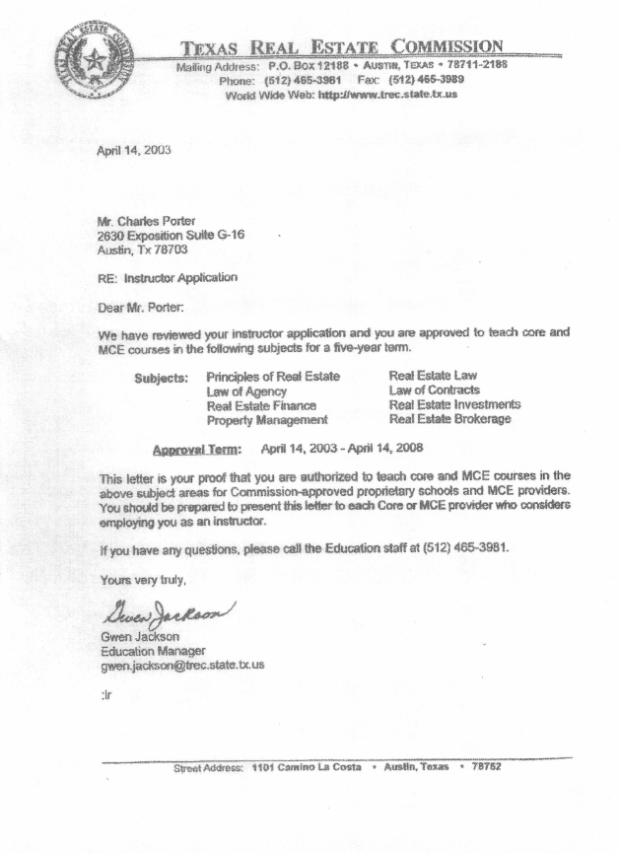

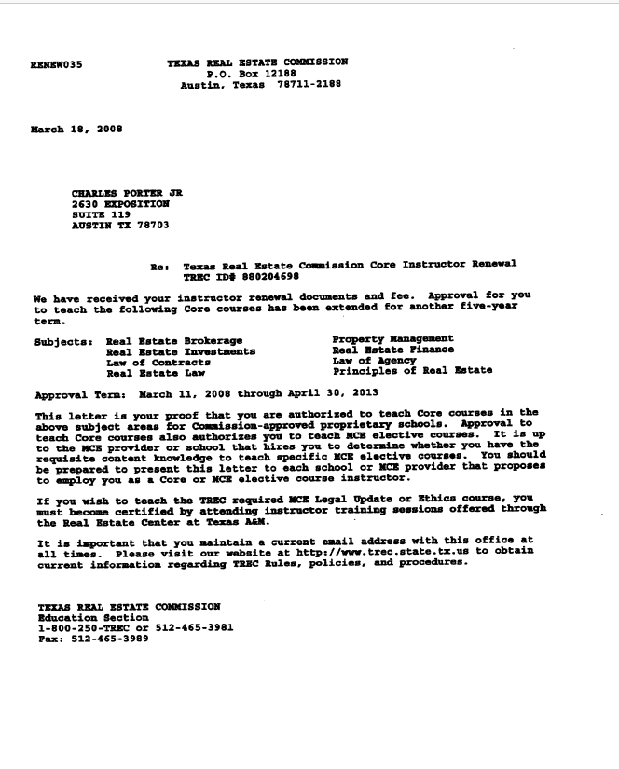

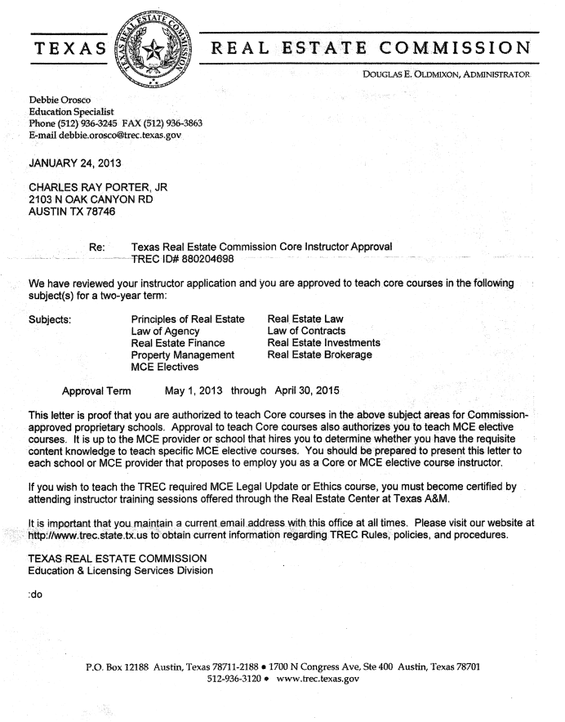

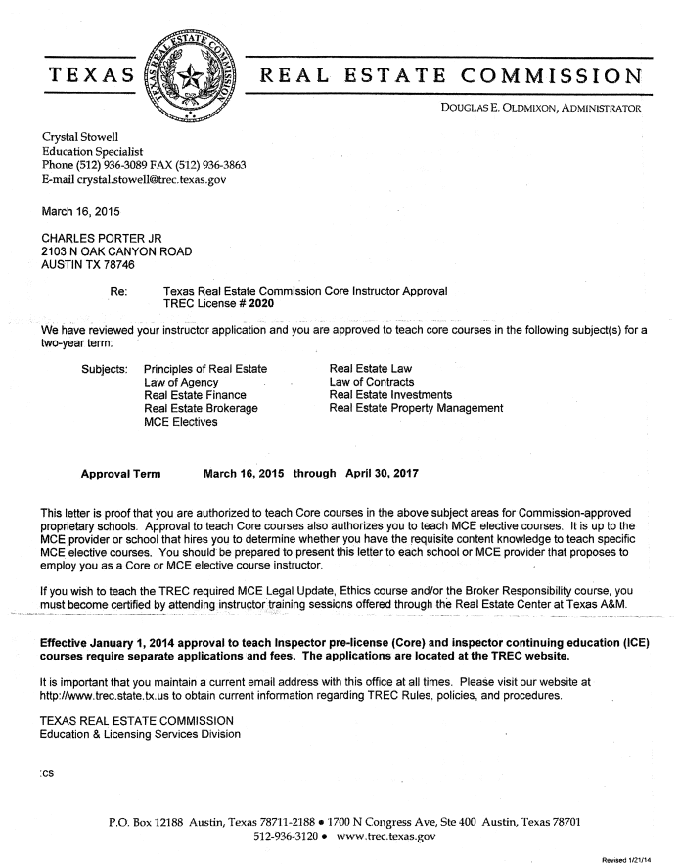

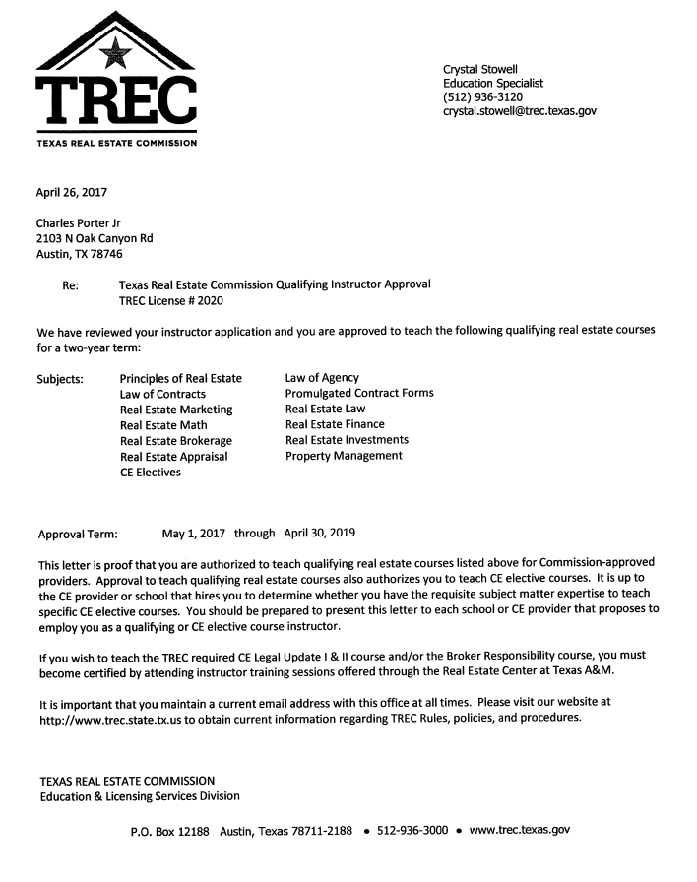

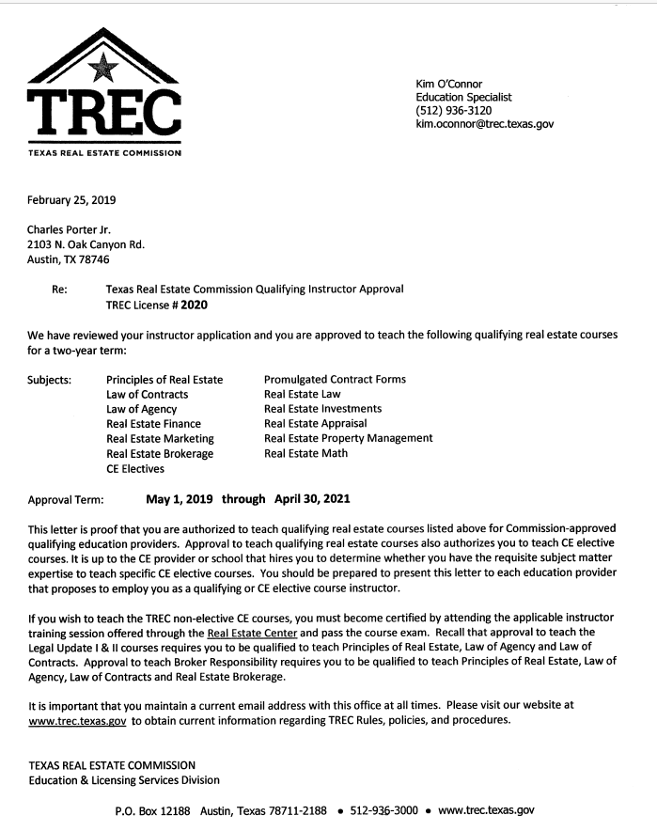

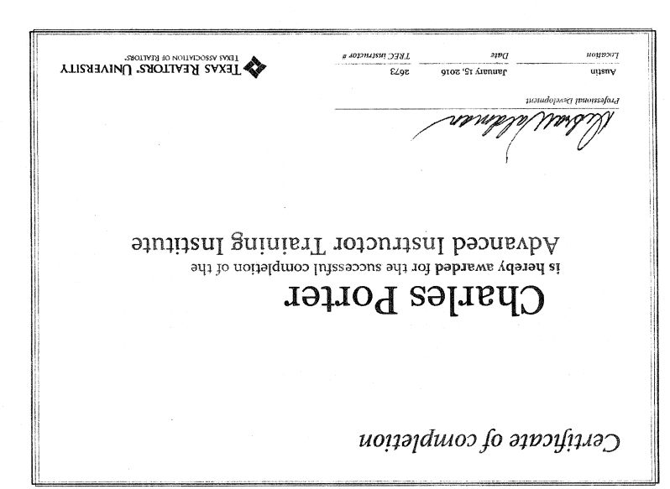

Other Awards and Community Service

1966 Eagle Scout Award, Boy Scouts of America
1969 Austin Area Kiwanis Education Award
1971 President, Phi Kappa Tau
1972 Round Up Chairman, University of Texas
1972-1974 Affiliated with Phi Gamma Delta Fraternity
1972 Elected Cactus Goodfellow
1972 & 1973 Elected President of the Interfraternity Council at the University of Texas
1973 Elected to Omicron Delta Kappa
1973 Who’s Who in Student Leaders in America
1973 Outstanding Young Men of America
1987 & 1988 President of Lynn Park Civic Association, a Homeowner’s Association
1987-1992 Board of Directors University of Texas Athletic Department Advisory Board, Houston Area
1987-1989 Board of Directors Texas Ex Students Association, Houston Area
1987-1991 Chairman of the Louis Pearce Bar B Que, University of Texas Athletic Department Advisory Board, Houston Area
1978-1991 Organized/ President of 14 Condominium or Homeowner’s Associations

